Delta Lake is an open-source storage layer that brings reliability to data lakes. Delta Lake provides ACID transactions, scalable metadata handling, and unifies streaming and batch data processing. Delta Lake runs on top of your existing data lake and is fully compatible with Apache Spark APIs.

**Creating Delta Table:**



**Output:**

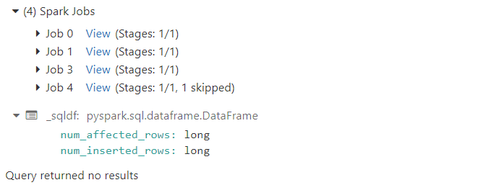

**Select operation on the delta table:**

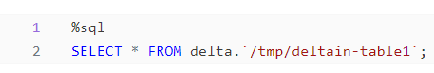

**Output:**

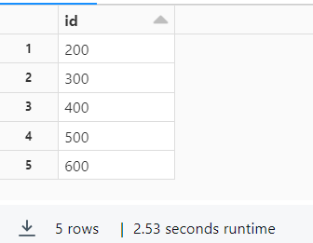

**Streaming data:**



**Output:**

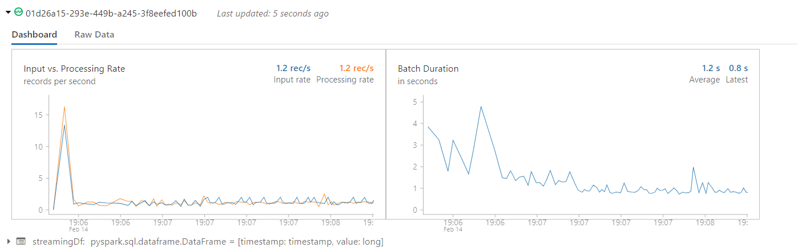

**Update, delete, merge and creating view for delta table:**

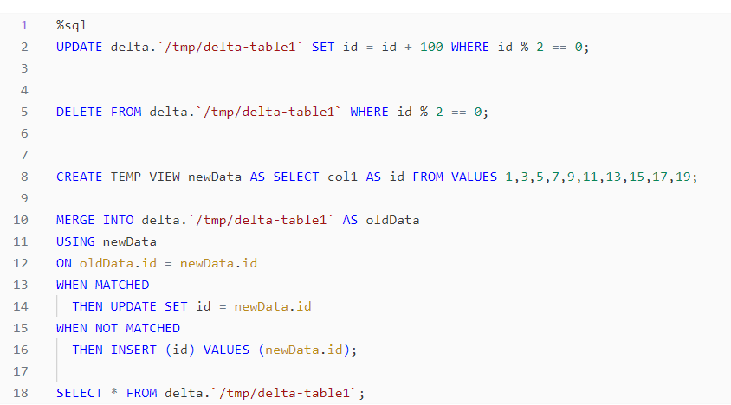

**Output:**

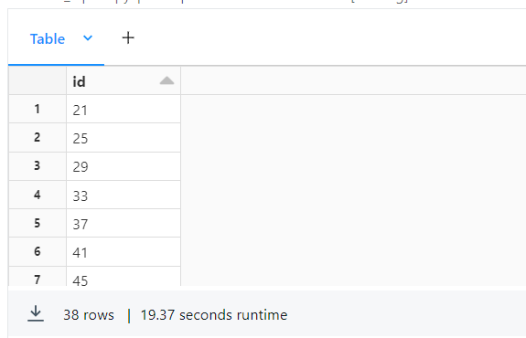

**Streaming the data after the changes:**



**Output:**

